Need to create the AI Testcase generator – using vibe coding with COT
Step1:
Create a folder and open the folder in Visual Studio code and copy the Prompt file (custom-html-for-langflow-chat.md)
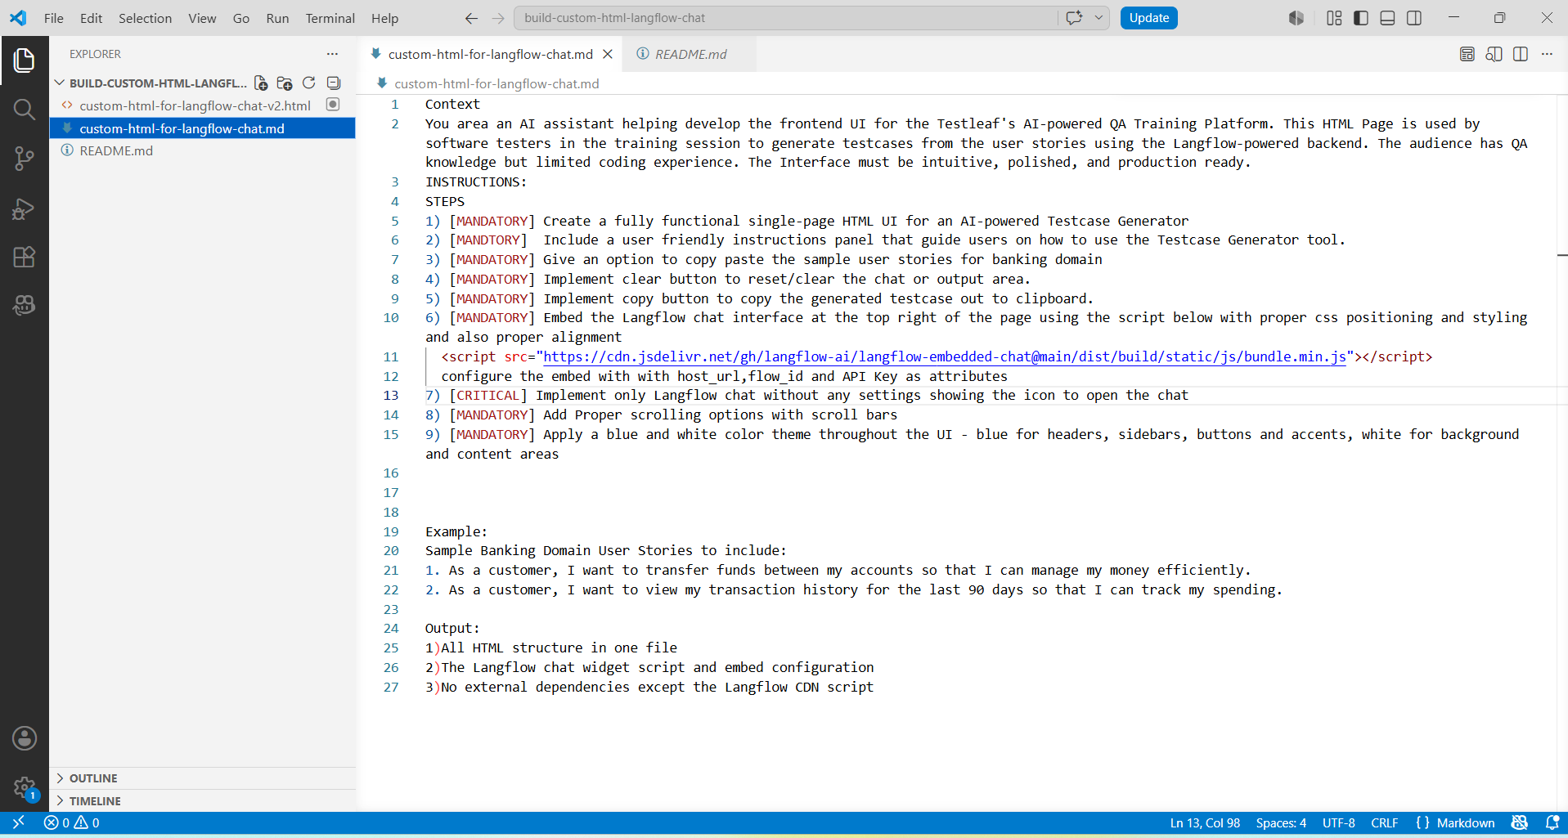
Step2: It creates the README.md file
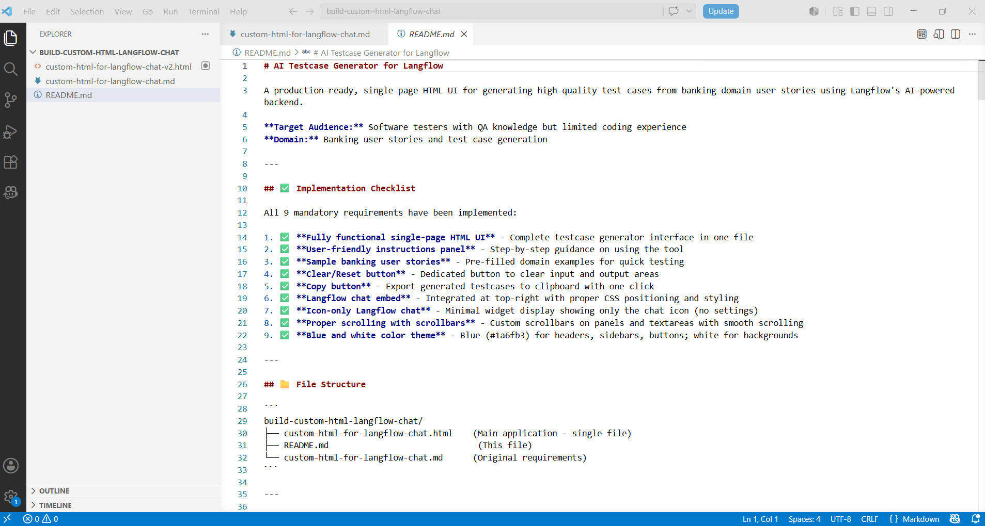
Step 3:
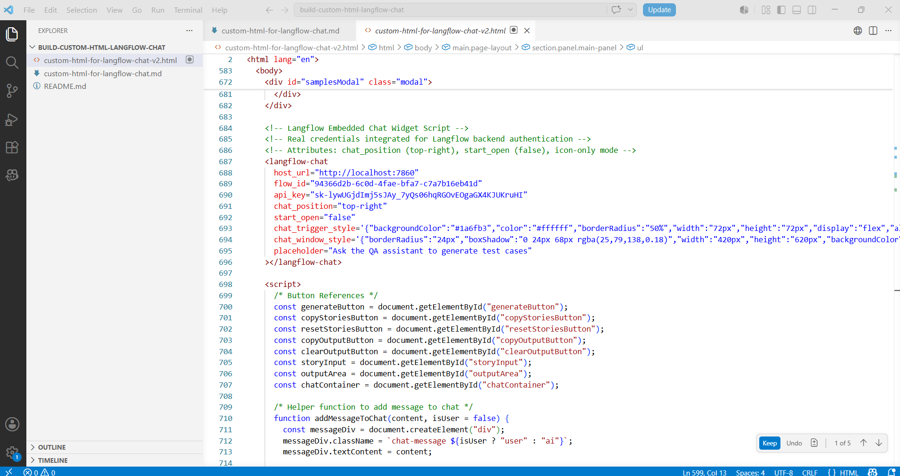
We have given the customized Lang flow chat window link provided here
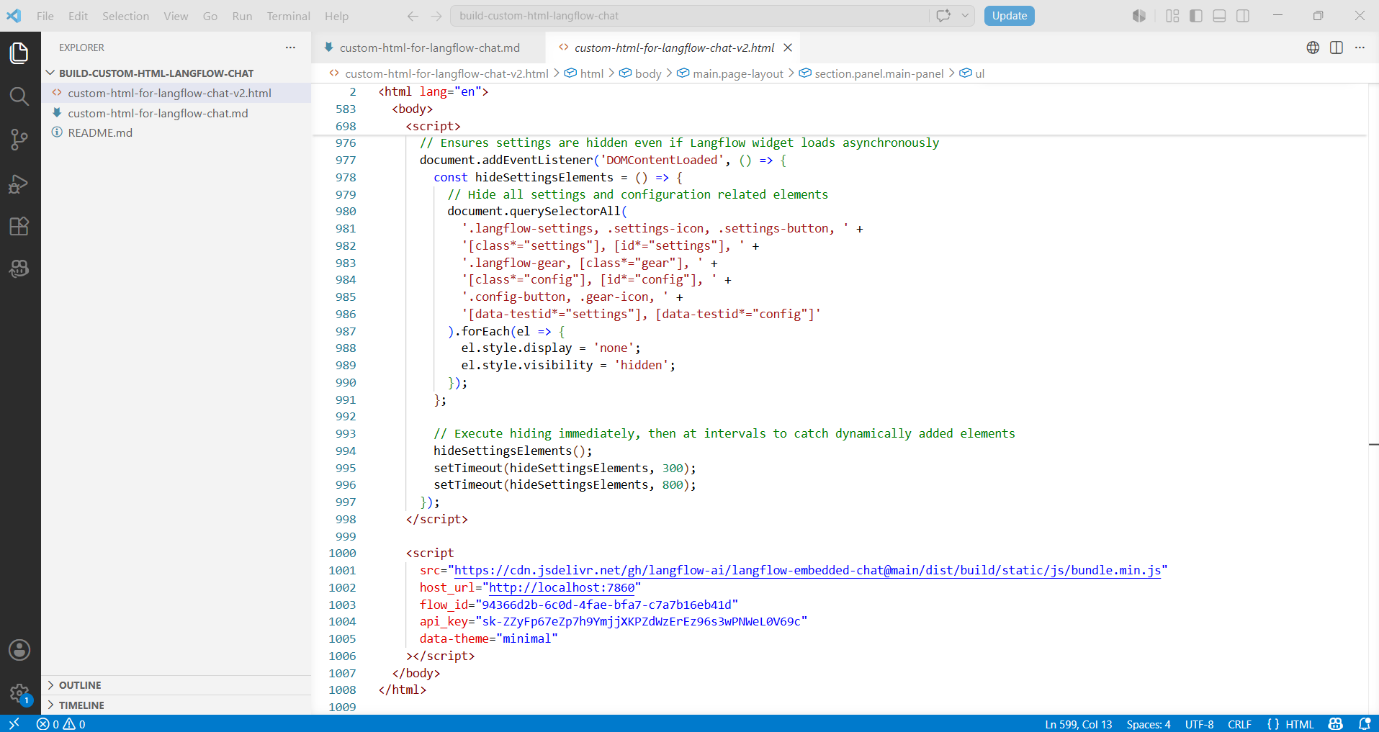
Step 4:
Created the AI Powered Testcase Generator:
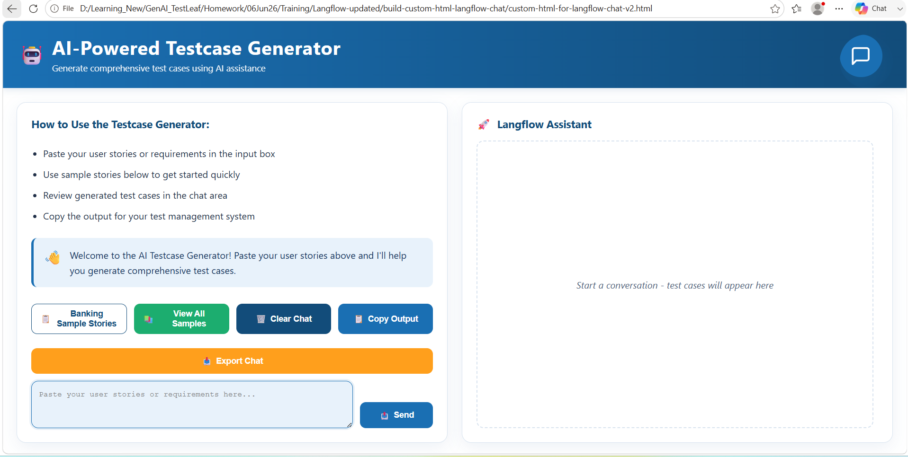
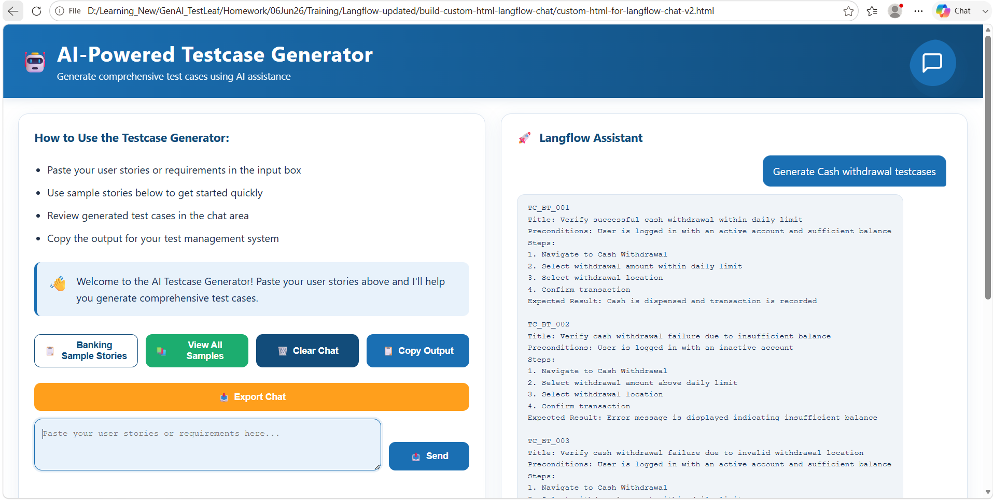
When clicked in “View All Samples”
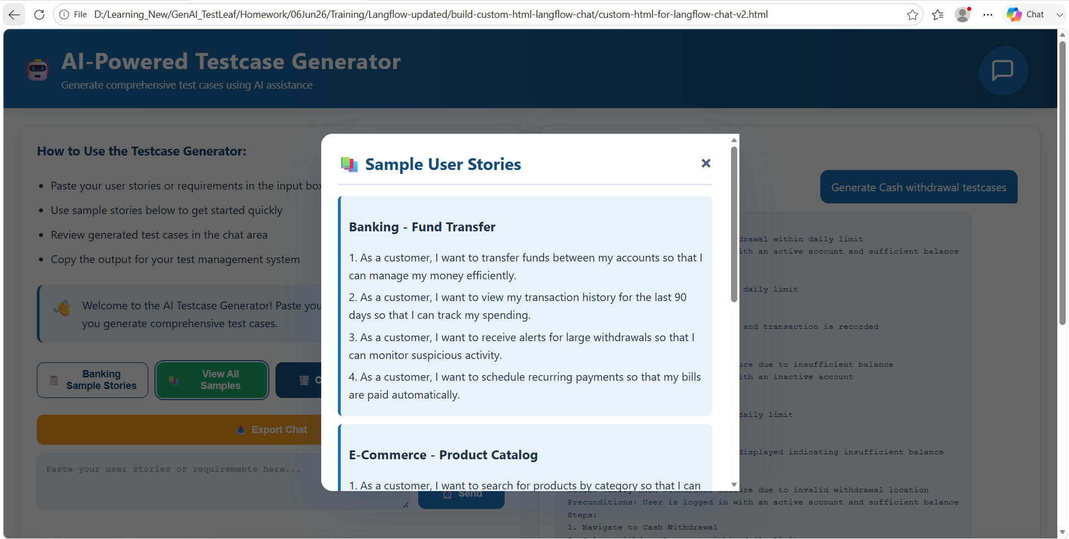
Click on the Export chat
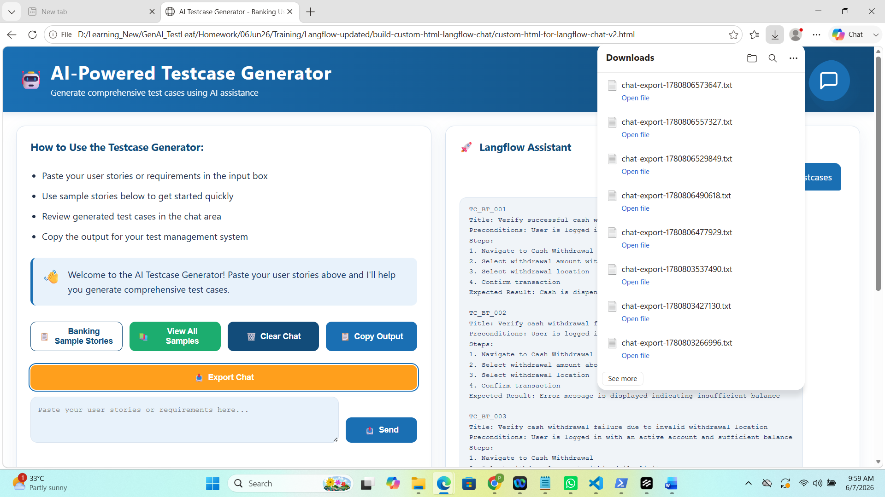
Click on “Copy Output”
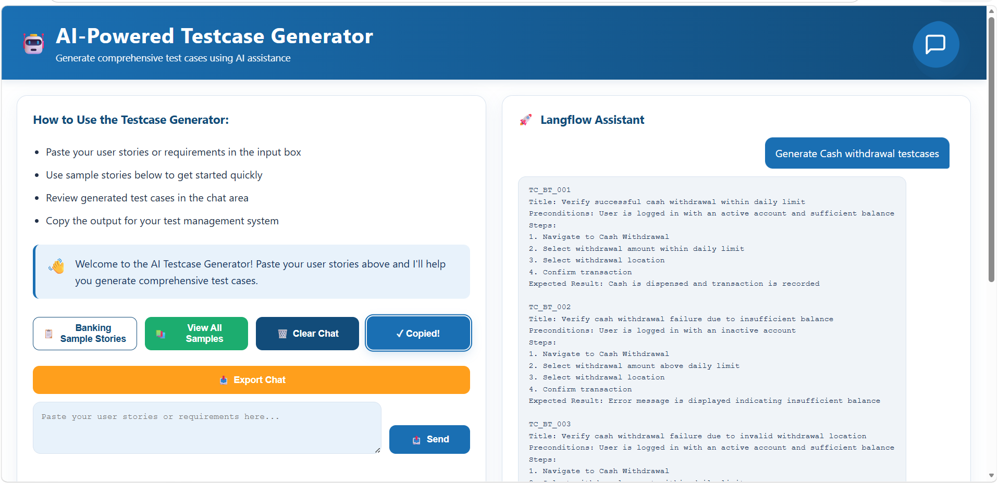
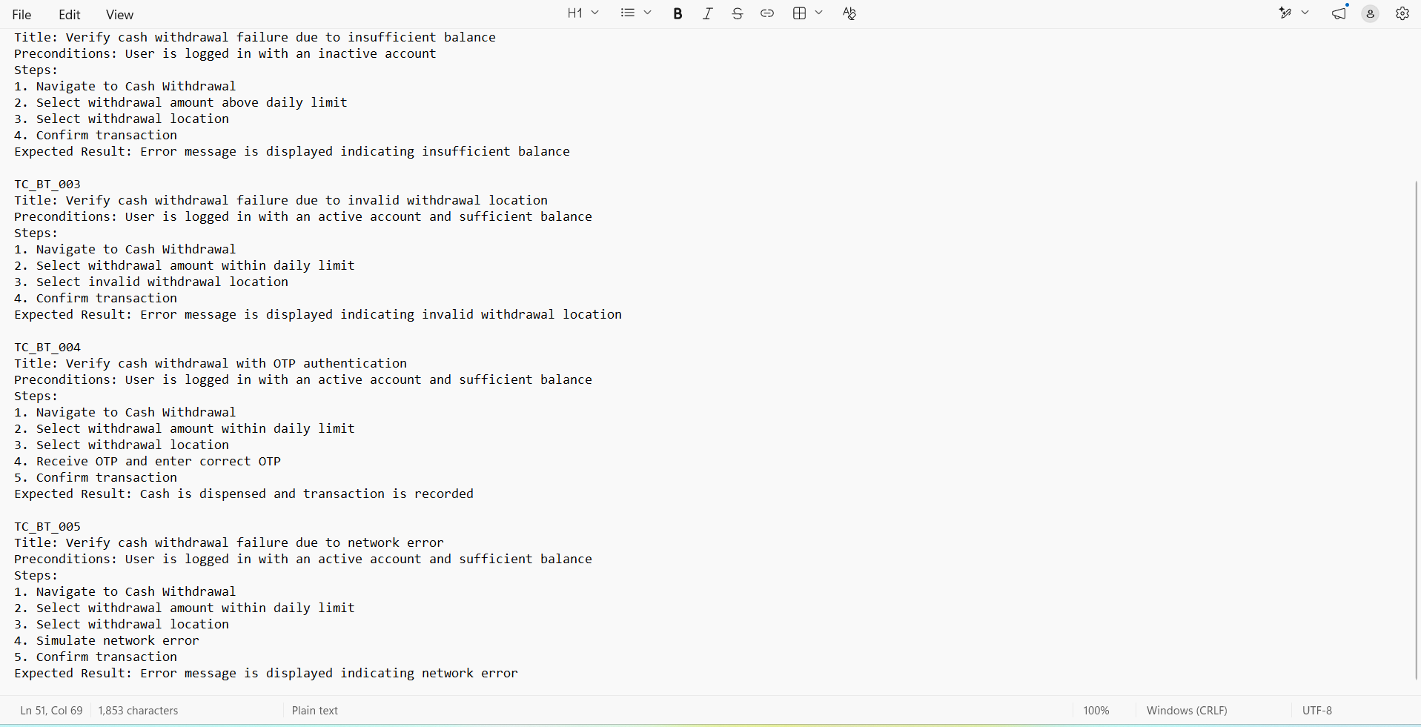
Click on “Clear Chat”
